Social Housing Law Association View in browser

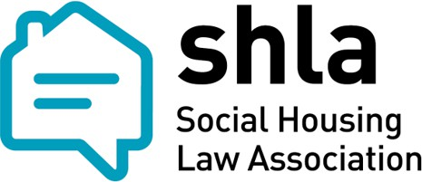

Newsletter


Welcome to the December Issue of the SHLA Newsletter
Our December newsletter is here, featuring updates and upcoming events from SHLA.

In this issue…

The Newsletter Committee - Iris Ferber KC (42BR Barristers), Dambu Tenner (Solicitor and Head of Legal, Abri) and Kate Hicks (Partner, Bevan Brittan) – welcome a series of guest writer articles providing key insights on a number of important issues.

All previous articles and webinar recordings remain available to all members via the SHLA website and we hope that this is a helpful resource for practitioners.

Articles

Our first article is from Genevieve Screeche-Powell and Andrew Burrell of Field Court Chambers: Genevieve led Andrew in the Court of Appeal, successfully defending the local authority in an 'intentional homelessness' challenge.

Next up, Senga Howells (Senior Associate) and Lauren Hampton (Associate) at Bevan Brittan LLP provide a useful summary of the impact of the Renters’ Rights Act 2025 on Shared Ownership leases. This is particularly timely, given that key changes are coming into force in just over a week, on 27 December 2025.

Finally, Anthony Woolich (Partner) and Aleksia Zivanovic (Trainee Solicitor) at Blake Morgan LLP take a deep dive into new “failure to prevent fraud” offences under the Economic Crime and Corporate Transparency Act 2024, which came into force on 1 September 2025.

All articles can be found in the members’ area of the SHLA website, here.


Housing Disrepair Claims: A Call For Evidence

The Ministry of Housing, Communities & Local Government, together with the Ministry of Justice, announced a call for evidence on 4 December 2025, in respect of housing disrepair claims and claims management.

This call “seeks views on cases where tenants in England consider seeking redress through the County Court by bringing a claim against their landlord for housing disrepair, and the role of claims management activity in this process”.

The call provides a fantastic opportunity for the sector to offer evidence to Government about how this area of litigation works in practice, and to comment on encounters which have taken place with claims management companies.

You will find the survey here and responses are welcomed from all interested parties, in particular tenants, landlords and solicitors.

SHLA will be holding a virtual round table event to discuss the call for evidence, to share experiences and to consider responses. This will take place on Zoom on 29 January, at 11am. Look out for more information, coming soon, about this members-only event.

Webinars

We hope you enjoyed our webinar series, please do give us your feedback. Newsletters
Please do give us your feedback – If there are any topics you think it would be useful for us to cover in forthcoming newsletters, please do send us your ideas.

If you are not a SHLA member, and would like more information about becoming a member, please email info@shla.org.uk.

We take this opportunity to wish you all a very restful festive period and we look forward to an exciting 2026 in store for SHLA, kicking off with our annual conference in March, more information on which is set out below.

Kate Hicks
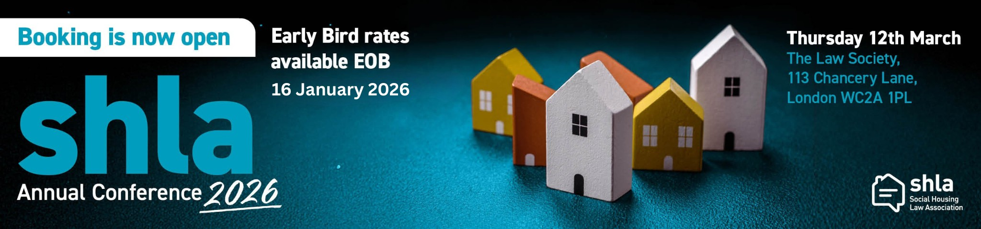
SHLA Committee Email:info@shla.org.uk

Annual Conference

The Social Housing Law Association (SHLA) Annual Conference will take place on Thursday 12 March 2026 at The Law Society, 113 Chancery Lane, London. This flagship event brings together professionals working across social housing law, including solicitors, barristers, in-house lawyers, housing associations and local authorities.

Designed to inform, challenge and connect, the SHLA Annual Conference provides a valuable forum for legal updates, sector-wide discussion and best-practice sharing on the regulatory and operational challenges facing social landlords.

The 2026 conference programme is now finalised, offering a full day of keynote speeches, expert panels, breakout sessions and networking opportunities. Attendees can expect insightful sessions covering housing management law, regulation, litigation and defence strategies, and emerging issues impacting the social landlord sector.

By attending, you will stay up to date with the latest legal developments, hear directly from leading practitioners, and have the opportunity to network with peers and sector stakeholders while deepening your understanding of the complex legal landscape in social housing.

Early bird rates are available until 16 January 2026, with discounted fees for members, students and group bookings. With a strong programme and excellent networking opportunities, the SHLA Annual Conference 2026 is not to be missed. Be sure to check out the programme and secure your place early.

BOOK HERE

Thank you to our 2026 Conference Sponsors:

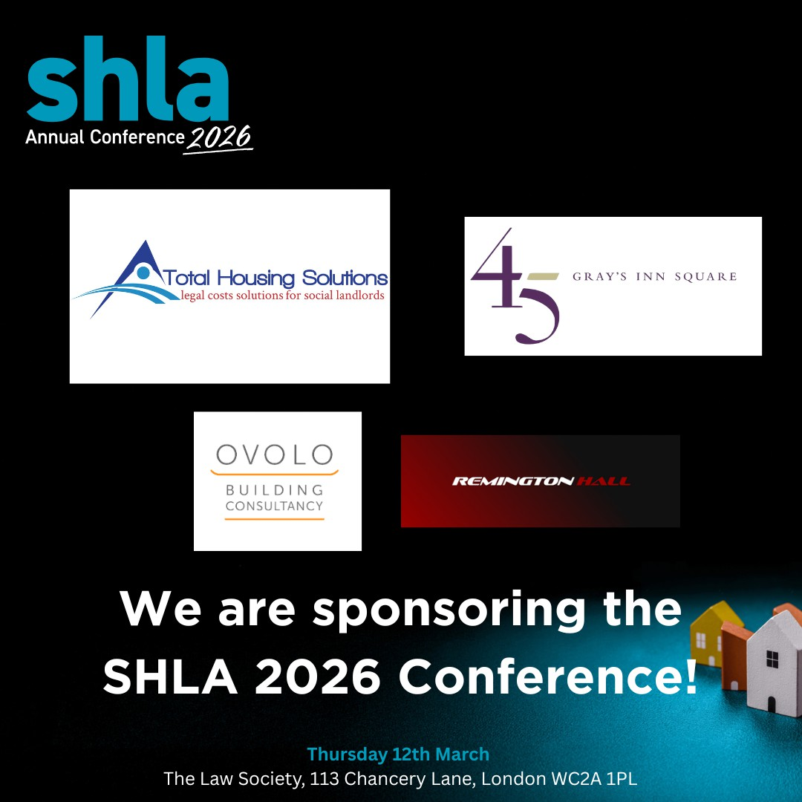


Become a Guest Writer


We always welcome articles that share the work you are doing in the sector. Send us your article ideas or offer to be a guest writer by contacting us at info@shla.org.uk

Merry Christmas and a Happy New Year from the SHLA Team!



Social Housing Law Association Unsubscribe

