Social Housing Law Association View in browser


Welcome

Our May newsletter is here, featuring updates and upcoming events SHLA.

Before we get into this issue of the newsletter, we wanted to take a moment to mark the death of Giles Peaker. His housing blog, Nearly Legal, was a highly respected and trusted source of legal updates and insights. It was read by judges, practitioners and lawyers – anyone who was a true housing professional. No one can doubt the mark that Giles left on the world of housing law, and he will be missed. Our thoughts are with his friends, family and colleagues at this sad time.

In this issue…

The Newsletter Committee - Iris Ferber KC (42BR Barristers), Dambu Tenner (Solicitor and Head of Legal, Abri) and Kate Hicks (Partner, Bevan Brittan) – welcome a series of guest writer articles providing key insights on a number of important issues.

Articles

Our first article is from Narin Masera, Solicitor, Devonshires Solicitors LLP who talks us through the Hillsborough Bill and what it means for the social housing sector.

Secondly, Rachel Payne, Associate Solicitor at MSB provides useful information on how social landlords can ensure that 2026 becomes the year of healthier tenancies.

Our last article is also from an Associate Solicitor of MSB, Beth Hyams, who highlights what we need to know on the reformed Decent Homes Standard.

All articles can be found in the members’ area of the SHLA website, here.

A look back at March 2026 Mazur
On the 31 March 2026 (earlier than expected but not surprising, considering the significant impact this case had on the legal world), the Court of Appeal handed down its judgment in Mazur v Charles Russell Speechlys LLP [2025] EWHC 2341 (KB). CILEX’s appeal was upheld. Key findings of the Court were:

- An unauthorised person may lawfully perform any tasks within the scope of the conduct of litigation for and on behalf of an authorised person (such as a solicitor or appropriately authorised CILEX member), provided the authorised person retains responsibility for the tasks delegated to the unauthorised person;
- The authorised person remains the person conducting the litigation;
- The unauthorised person is not conducting the litigation, and therefore does not commit an offence;
- The delegation of tasks by the authorised person to the unauthorised person requires proper direction, management supervision and control;
- The degree of appropriate control and supervision will always depend on the circumstances.

Below is a link to the Law Society’s updated Practice Note (which you will need to log in to read)

https://www.lawsociety .org.uk/topics/regulation/mazur-and-the-conduct-of-litigation

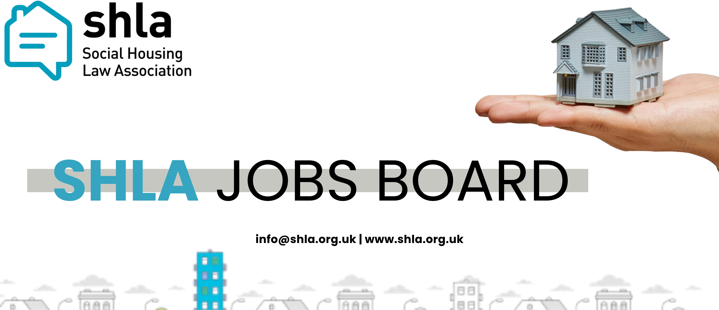
Don’t forget members can advertise on our website for free and non-members can advertise at a very competitive price of £50 If you would like to advertise a job on our website please contact info@shla.org.uk.

Dates for your Diary

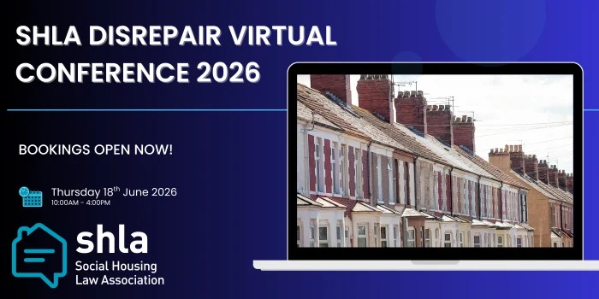
Disrepair Virtual Conference: 18 June 2026, 10 am - 4 pm

Aimed at professionals working in social housing, this conference is an unmissable opportunity to hear from expert panels on a variety of topics including ADR, costs to case updates from the last 12 months. Delegates will also be able to hear and share their top tips for managing housing condition claims.

To find out more and book your place

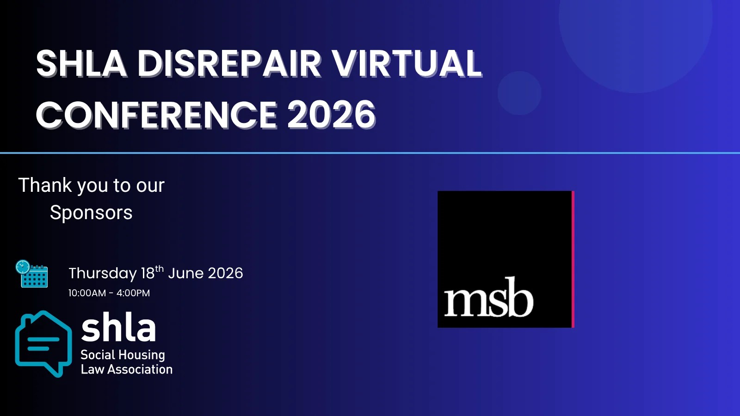
Sponsorship Opportunities

If you are interested in sponsoring our Disrepair Virtual Conference 2026, contact us at

info@shla.org.uk.


Become a Guest Writer

We always welcome articles that share the work you are doing in the sector. Send us your article ideas or offer to be a guest writer by contacting us at info@shla.org.uk

Please do give us your feedback, and join us for our next event, where we will continue to provide insights in to the most pressing issues for social housing law practitioners. If there are any topics it would be useful for us to cover in forthcoming newsletters, please do send us your ideas.

If you are not a SHLA member and would like more information, please email info@shla.org.uk.

Dambu Tenner, SHLA Committee
Email:info@shla.org.uk




Social Housing Law Association Unsubscribe

