Social Housing Law Association View in browser


Welcome

Our July newsletter is here, featuring updates and upcoming events SHLA. In this issue…
The Newsletter Committee - Iris Ferber KC (42BR Barristers), Dambu Tenner (Solicitor and Head of Legal, Abri) and Kate Hicks (Partner, Bevan Brittan) – welcome a series of guest writer articles providing key insights on a number of important issues.

Articles

Our first article is from Sarah Orchard, Senior Associate, Bevan Brittan, who takes us through the proposed reforms to the Right to Buy.

Secondly off the back of our successful virtual Disrepair Conference, we keep to the theme with Alex Bagnall, Technical Manager, Total Housing Solutions who talks us through a recent disrepair costs case

Our last article is in honour of ASB Awareness week (29 June 2026 – 5 July 2026) and is from, Aman Guru, Associate, at Bevan Brittan who looks at the impact delays in the court system have on managing ASB in the community..

All articles can be found in the members’ area of the SHLA website, here.

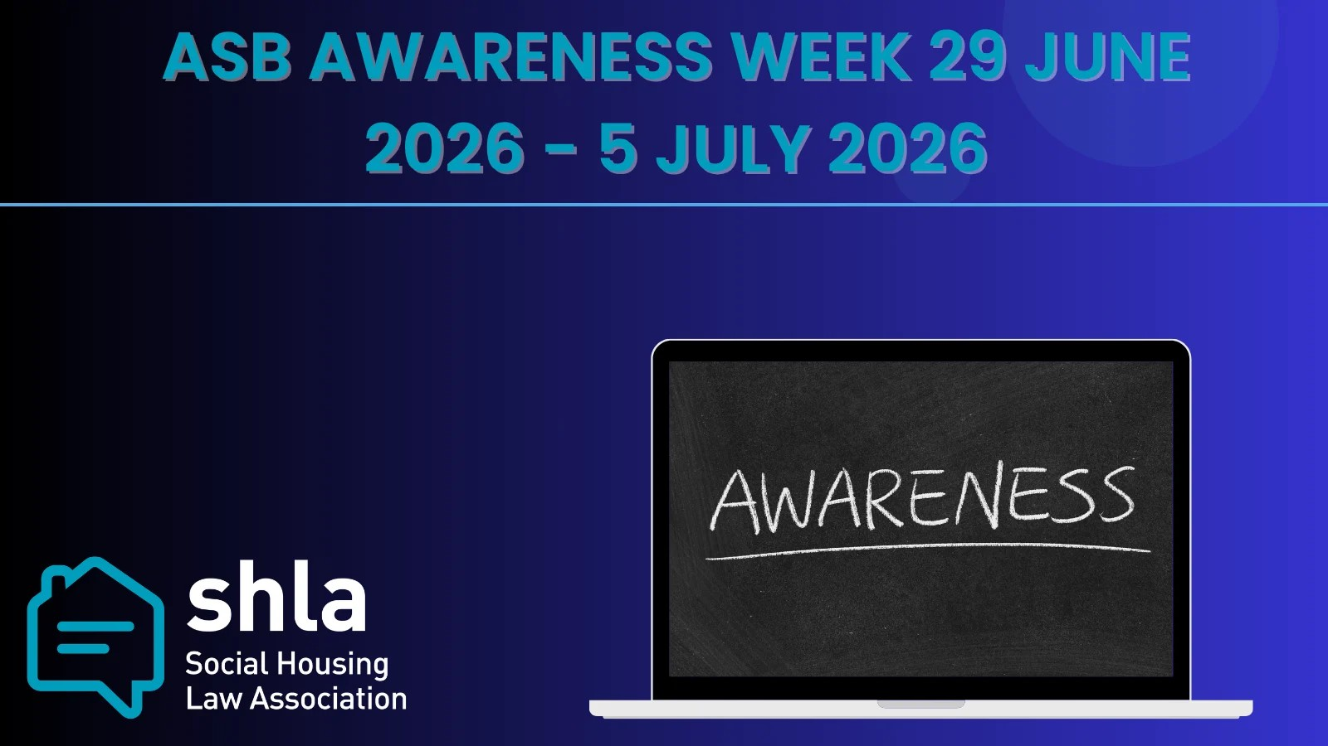

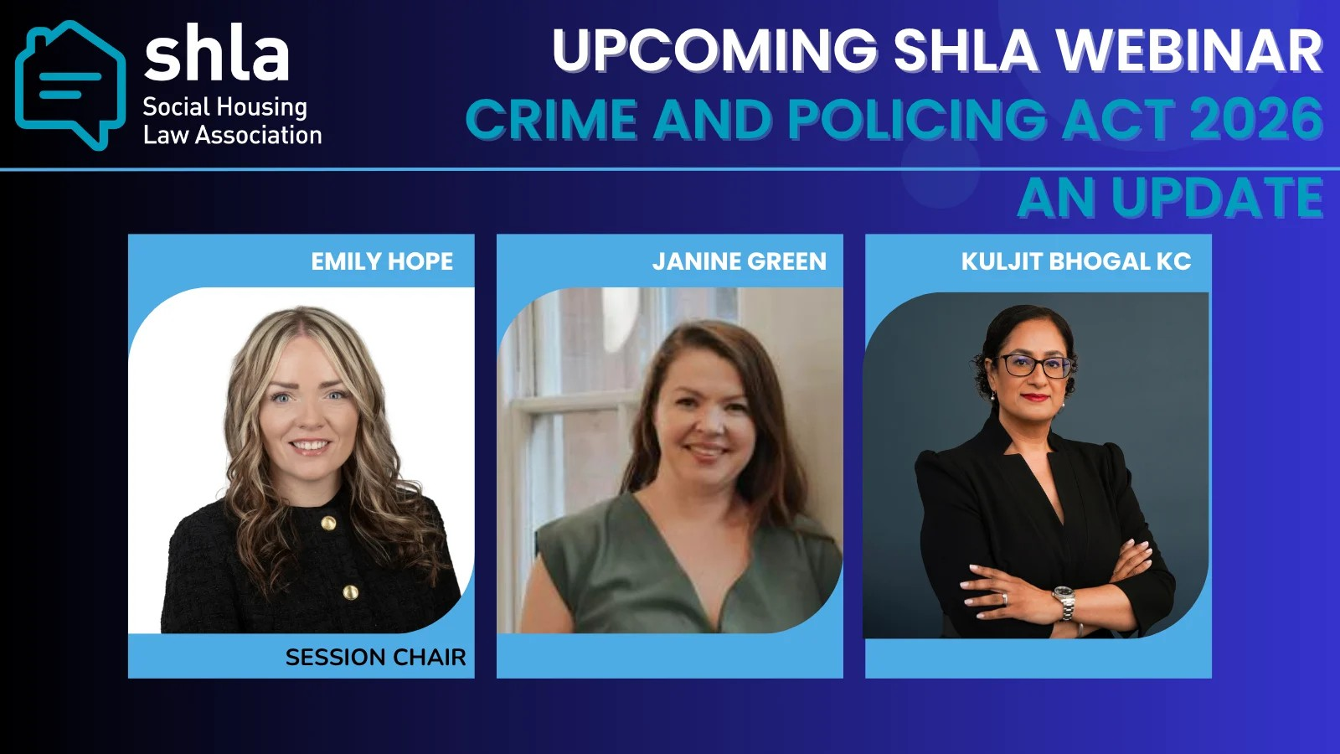
ASB Awareness week – Crime and Policing Act 2026 Updates - July 3 @ 14:00 - 15:00 Webinar

Mark ASB week by joining Emily Hope (SHLA Committee Member/Clark Wilmott), Jannie Green (G&B ASB associates) and Kuljit Bhogal KC (Cornerstone Barristers) as they provide useful updates on the Crime and Policing Act 2026

FOR MORE INFORMATION AND TO BOOK YOUR PLACE

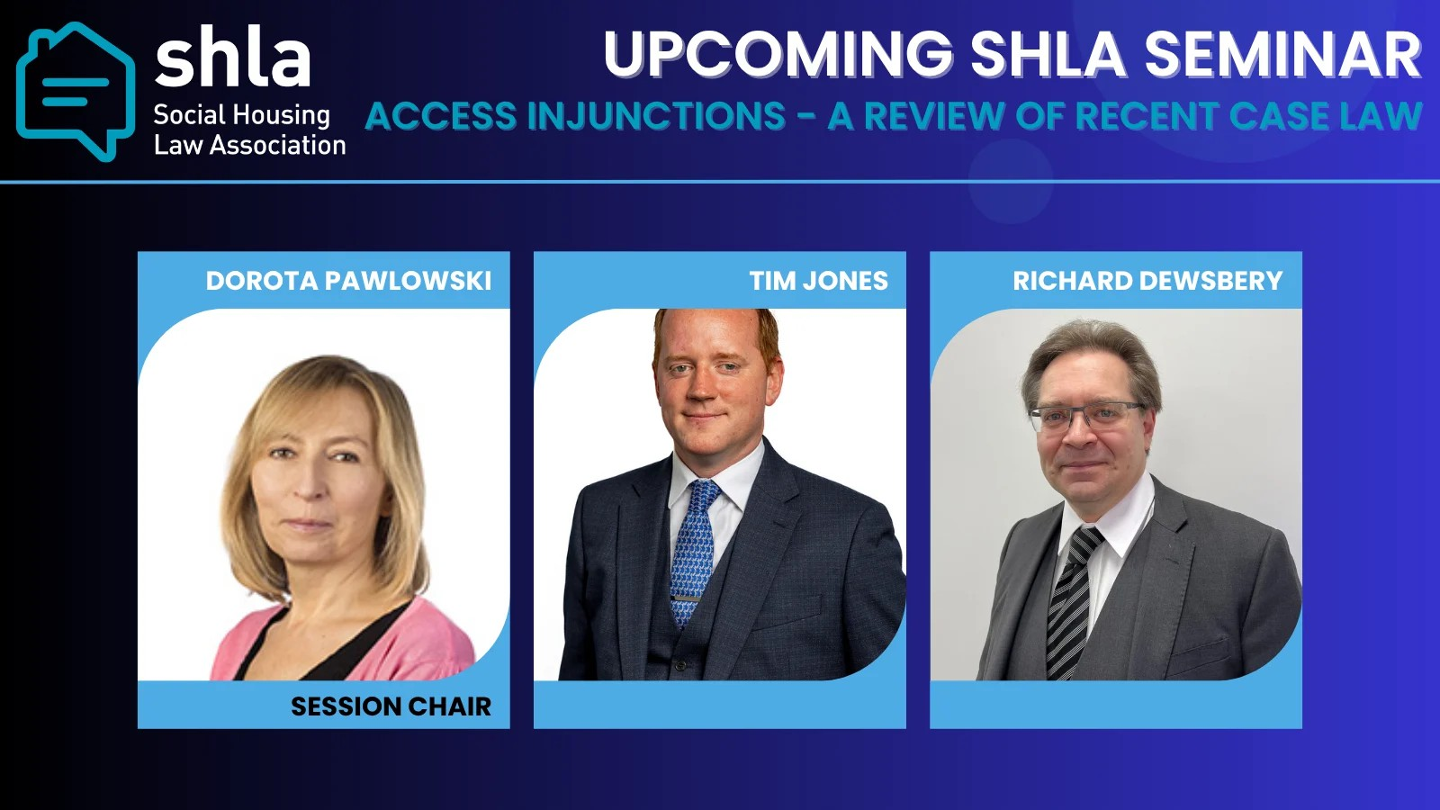
July 2 @ 17:00 - 19:00 In-person event - Birmingham

Access injunctions – a review of recent case law, with particular emphasis on forced access provisions, followed by a round table discussion as to regional practices

FOR MORE INFORMATION AND TO BOOK YOUR PLACE

More Upcoming Webinars

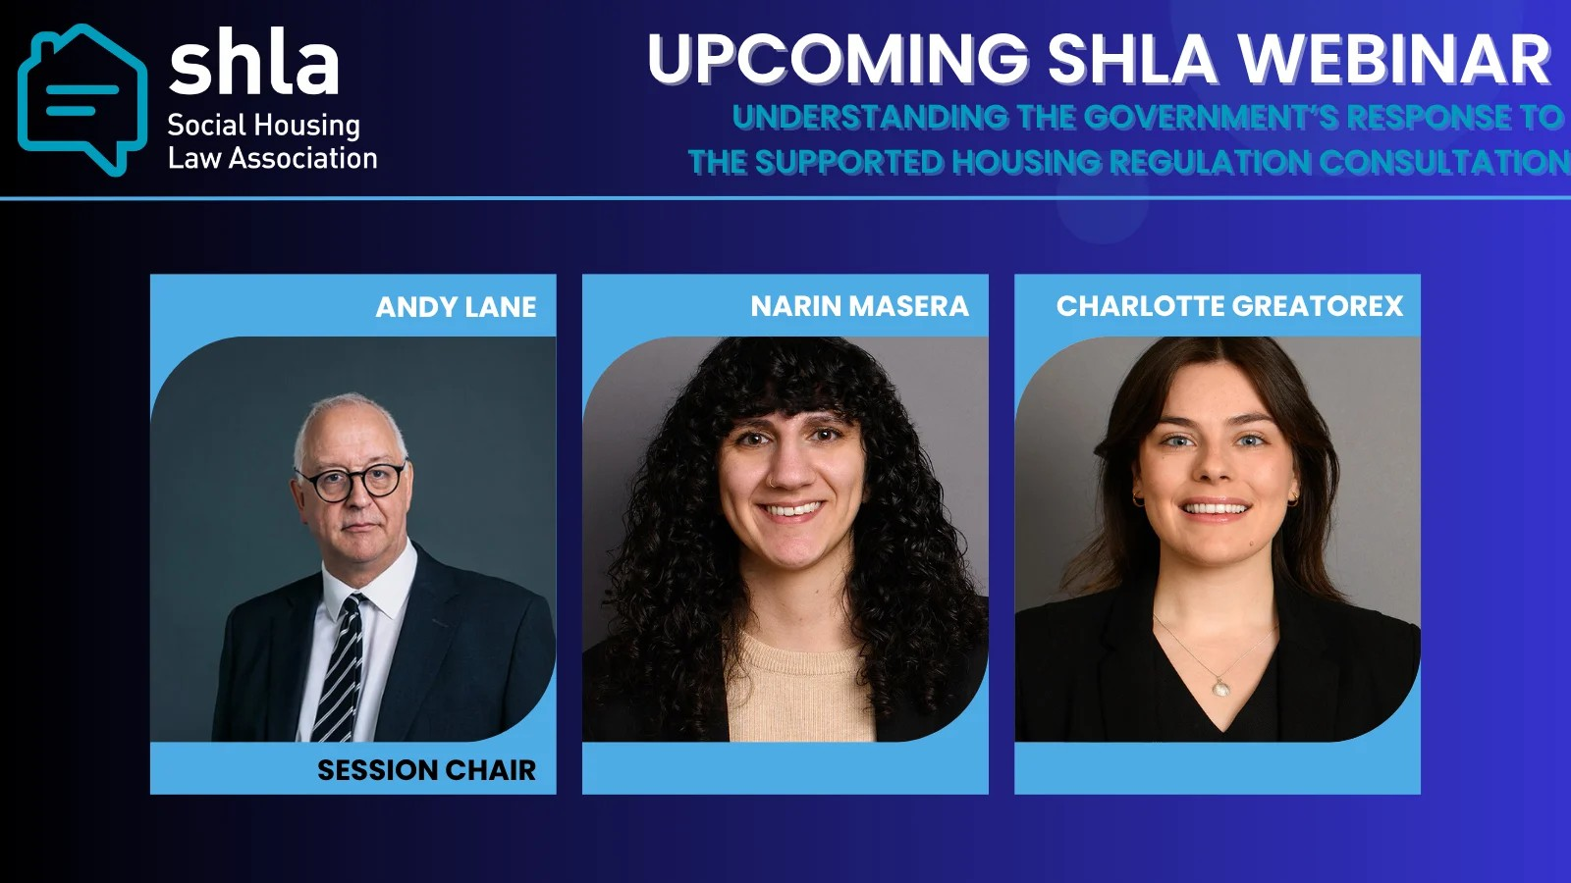
July 8 @ 11:00 - 12:00 Webinar

Understanding the Government’s Response to the Supported Housing Regulation Consultation

FOR MORE INFORMATION AND TO BOOK YOUR PLACE


SHLA JOBS BOARD

Don’t forget members can advertise on our website for free and non-members can advertise at a very competitive price of £50 If you would like to advertise a job on our website please contact info@shla.org.uk.


Become a Guest Writer

We always welcome articles that share the work you are doing in the sector. Send us your article ideas or offer to be a guest writer by contacting us at info@shla.org.uk

Please do give us your feedback, and join us for our next event, where we will continue to provide insights in to the most pressing issues for social housing law practitioners. If there are any topics it would be useful for us to cover in forthcoming newsletters, please do send us your ideas.

If you are not a SHLA member and would like more information, please email info@shla.org.uk.

Dambu Tenner, SHLA Committee
Email:info@shla.org.uk




Social Housing Law Association Unsubscribe

